Test Case: tc001_SPX_Dev5_Crear_Requisicion_Spot_Tipo_Cobro_CC
Step 1 - Enter username and password and click to button Enter : Credentials Entered
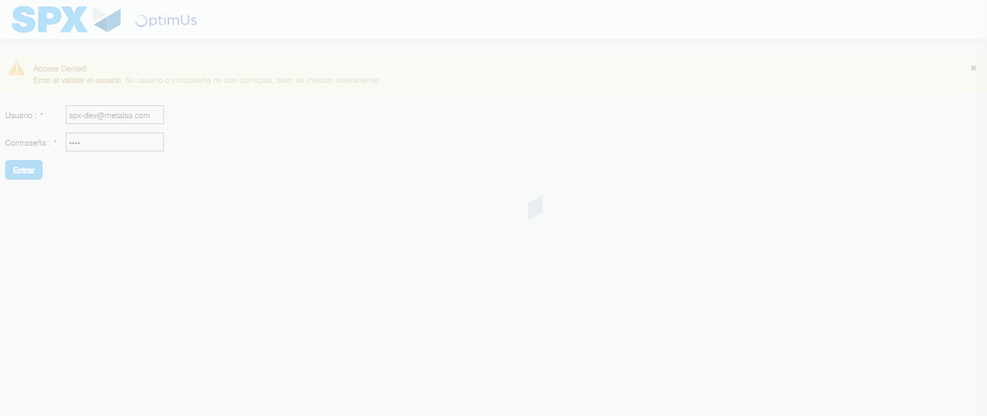Image file-name: QC_Testing-tc001_SPX_Dev5_Crear_Requisicion_Spot_Tipo_Cobro_CC-1789482482501

Step 2 - Select to UEN and Access to Spot Buy Requisitions : UEN Correctly selected and Correct access
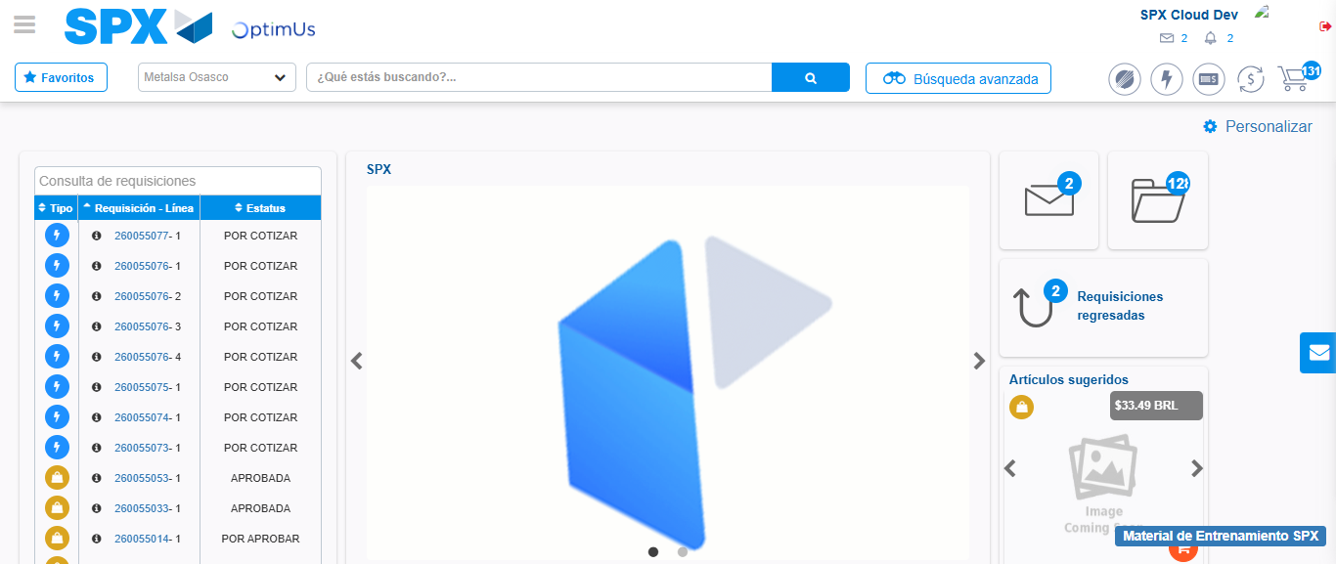Image file-name: QC_Testing-tc001_SPX_Dev5_Crear_Requisicion_Spot_Tipo_Cobro_CC-1789482514418

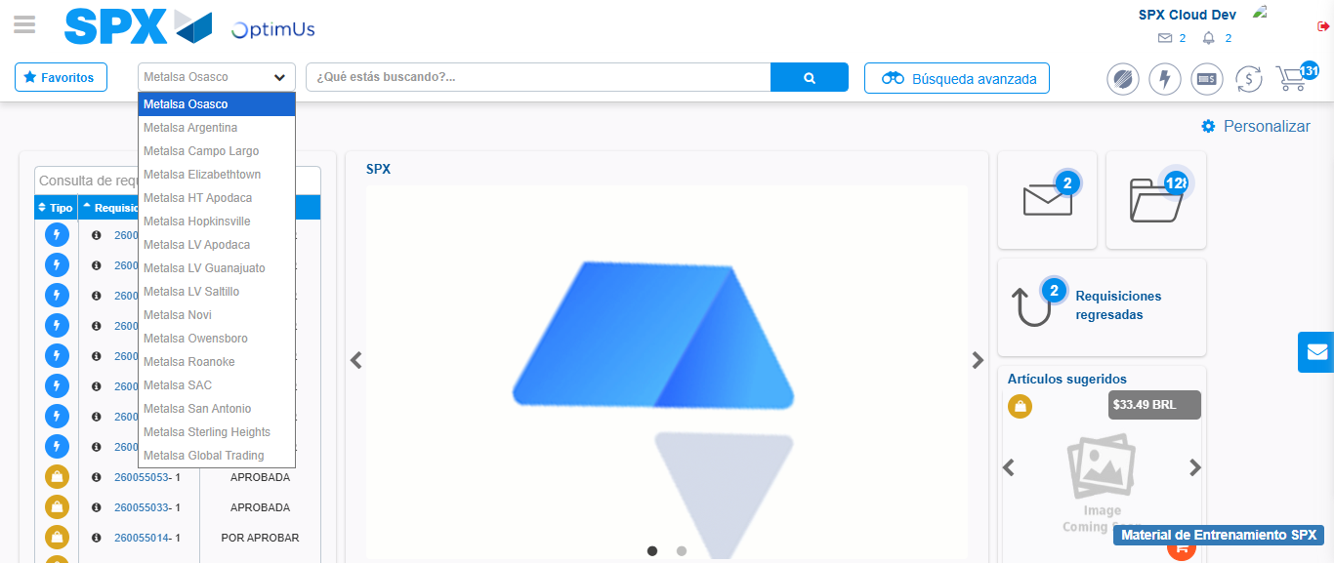Image file-name: QC_Testing-tc001_SPX_Dev5_Crear_Requisicion_Spot_Tipo_Cobro_CC-1789482515066

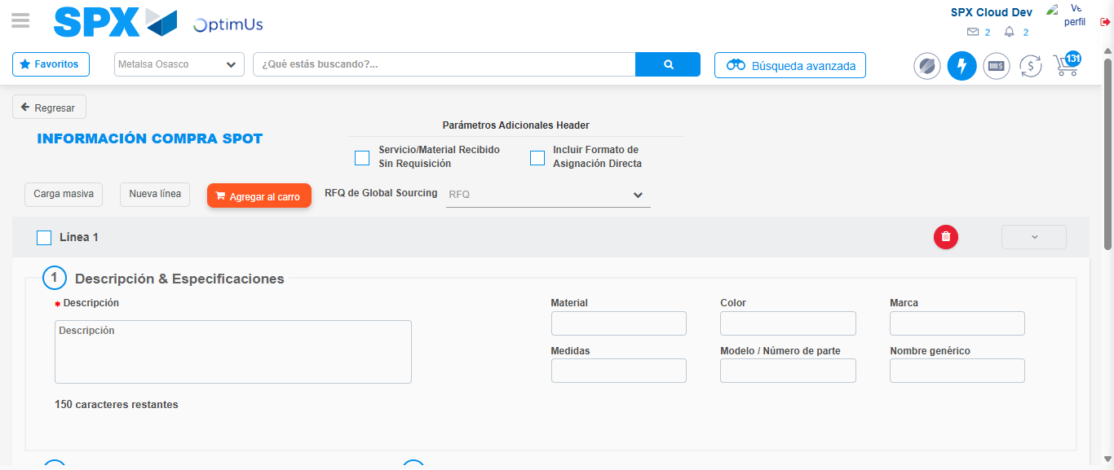Image file-name: QC_Testing-tc001_SPX_Dev5_Crear_Requisicion_Spot_Tipo_Cobro_CC-1789482519946

Step 3 - Data Capture Spot Buy Requisition : Data captured correctly
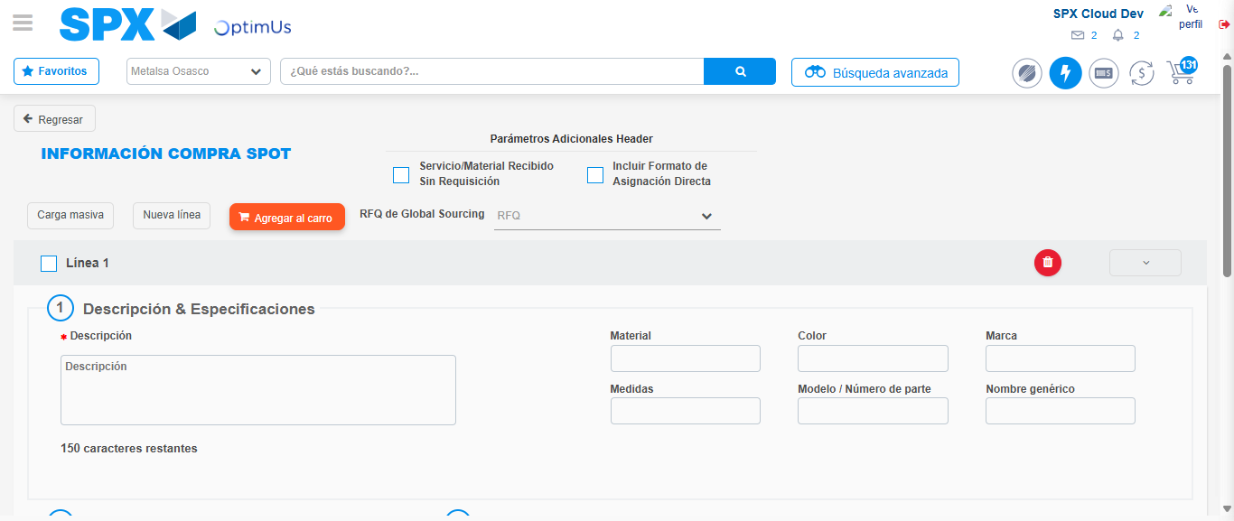Image file-name: QC_Testing-tc001_SPX_Dev5_Crear_Requisicion_Spot_Tipo_Cobro_CC-1789482520217

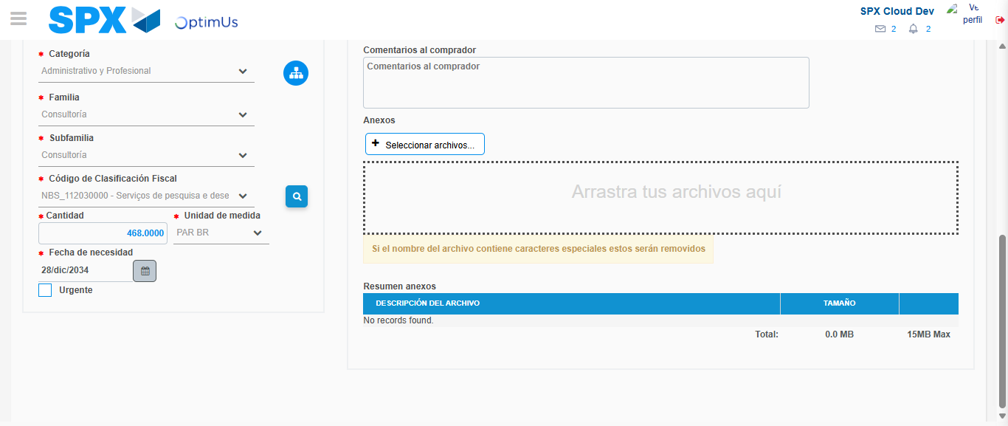Image file-name: QC_Testing-tc001_SPX_Dev5_Crear_Requisicion_Spot_Tipo_Cobro_CC-1789482537098

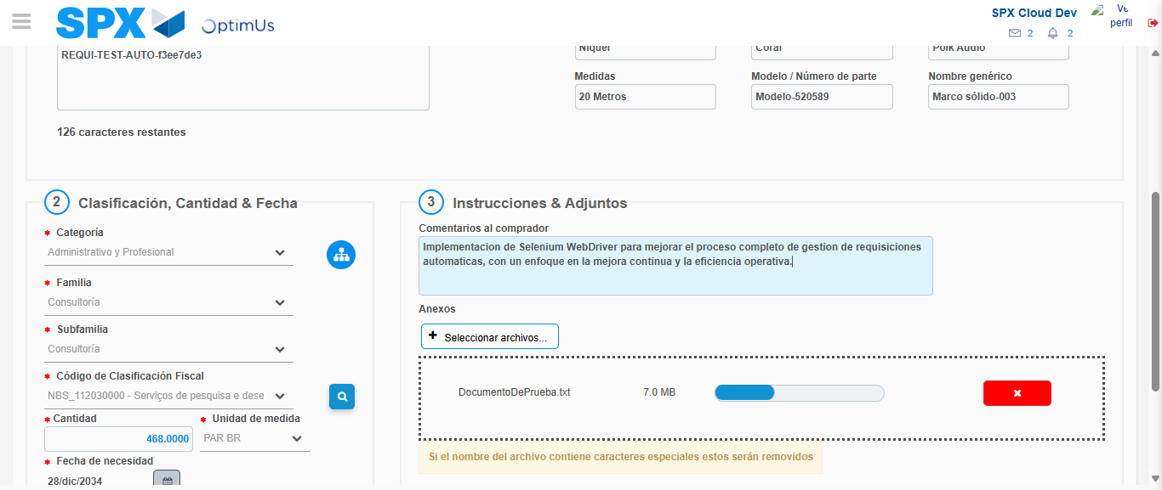Image file-name: QC_Testing-tc001_SPX_Dev5_Crear_Requisicion_Spot_Tipo_Cobro_CC-1789482538050

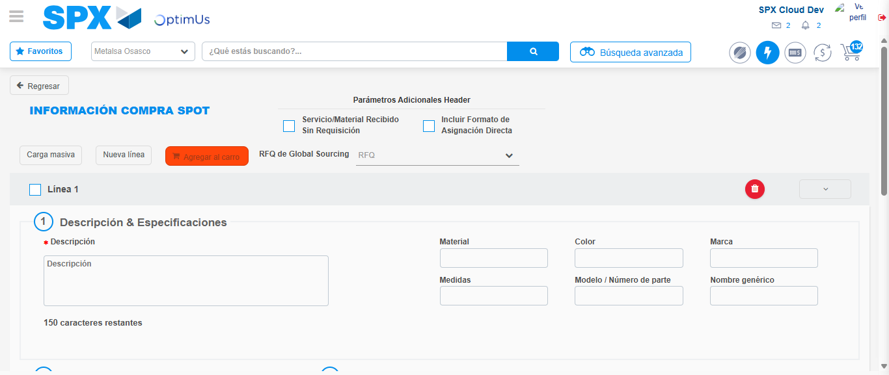Image file-name: QC_Testing-tc001_SPX_Dev5_Crear_Requisicion_Spot_Tipo_Cobro_CC-1789482539644

Step 7 - Return to Main Page SPX : Return to Main Page SPX
Image file-name: QC_Testing-tc001_SPX_Dev5_Crear_Requisicion_Spot_Tipo_Cobro_CC-1789482514418

Image file-name: QC_Testing-tc001_SPX_Dev5_Crear_Requisicion_Spot_Tipo_Cobro_CC-1789482515066

Image file-name: QC_Testing-tc001_SPX_Dev5_Crear_Requisicion_Spot_Tipo_Cobro_CC-1789482519946

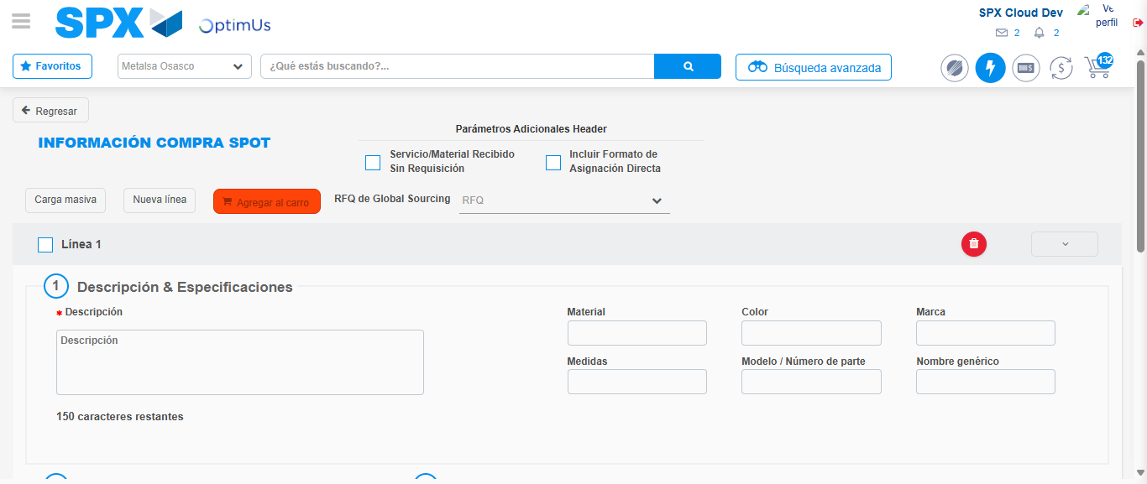Image file-name: QC_Testing-tc001_SPX_Dev5_Crear_Requisicion_Spot_Tipo_Cobro_CC-1789482541896

Image file-name: QC_Testing-tc001_SPX_Dev5_Crear_Requisicion_Spot_Tipo_Cobro_CC-1789482542086

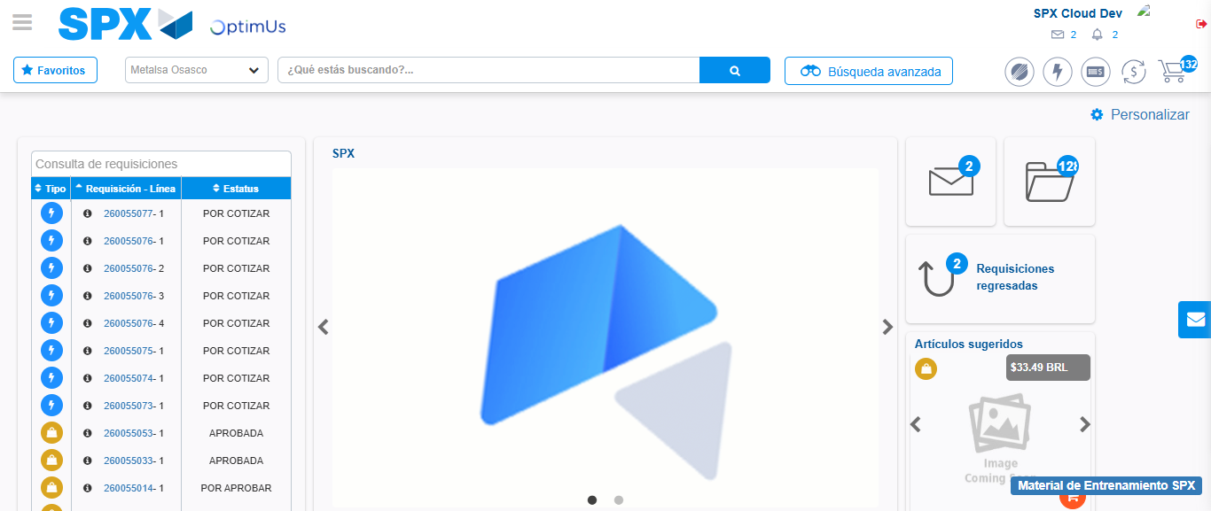Image file-name: QC_Testing-tc001_SPX_Dev5_Crear_Requisicion_Spot_Tipo_Cobro_CC-1789482563472

Step 8 - Log Out : Log Out SPX
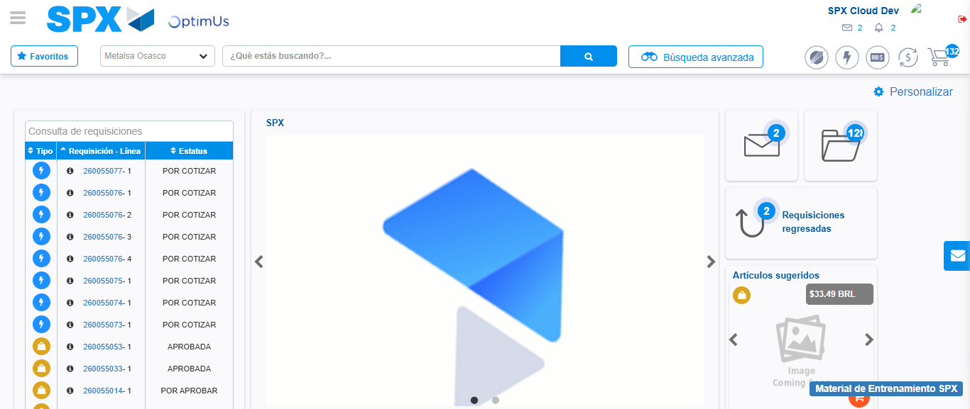Image file-name: QC_Testing-tc001_SPX_Dev5_Crear_Requisicion_Spot_Tipo_Cobro_CC-1789482563760

